Jaypee Institute of Information Technology, Noida-128
CN Lab (15B17CI571) Exercises
5th Semester – 2018 (Odd Semester)
Evaluation Scheme:-
Day to Day Evaluation + CN Lab Project: 60 Marks
Lab Test‐1: 20 Marks
Lab Test‐2: 20 Marks
Instructions for the Lab
- Students having Lab attendance <60%, will be awarded ZERO Marks in D2D marks.
- If a student is absent on the day of evaluation, will be awarded ZERO for that evaluation.
- Turn off your systems before leaving lab.

Lab 7

Objective: Goal of this lab is to familiarize with network simulator and how to run a simple program.

Step #1:- Create a script that simulates the simplest topology:
Node #1
(SENDER)
Node #2
(RECEIVER)

Data
1 Mb 10 ms

Step #2:- Now write following script in a text file (with extension of *.tcl):
#Create a simulator object
set ns [new Simulator]
#Open the nam trace file
set nf [open out.nam w]
$ns namtrace-all $nf
#Define a 'finish' procedure
proc finish {} {
global ns nf
$ns flush-trace
#Close the trace file
close $nf
#Execute nam on the trace file
exec nam out.nam&
exit 0
}
#Create two nodes
set n0 [$ns node]
set n1 [$ns node]
#Create a duplex link between the nodes
$ns duplex-link $n0 $n1 1Mb 10ms DropTail
#Call the finish procedure after 5 seconds of simulation time
$ns at 5.0 "finish"
#Run the simulation
$ns run

Step #3:- Execute this code:
ns example1a.tcl

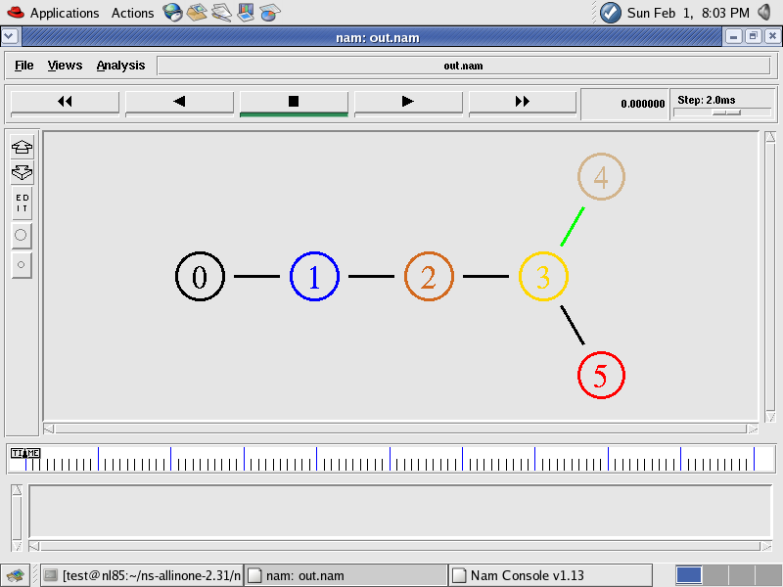

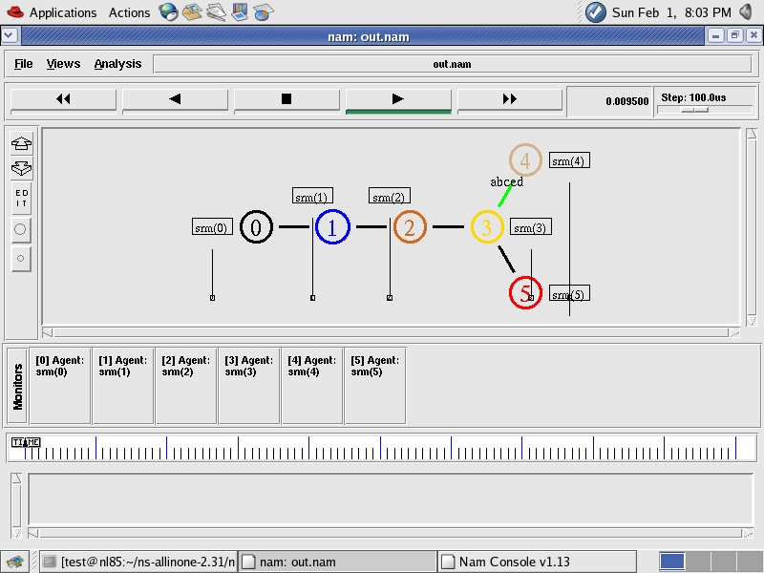

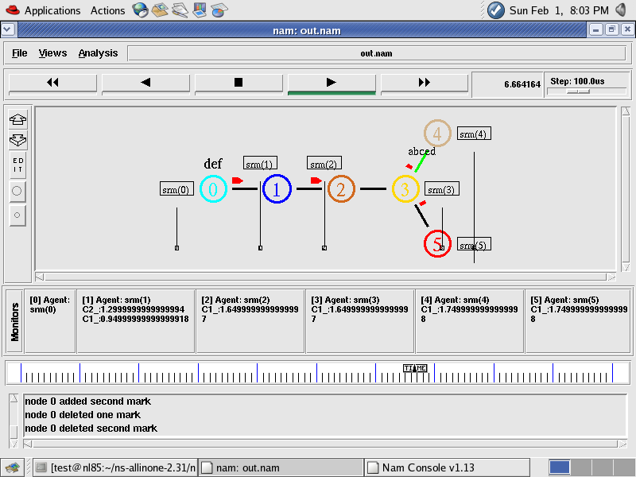

Example 2:- Build a script to simulate following network simulator scenario:

Node #0
(SENDER)
Node #3
(RECEIVER)

Node #1
(SENDER)

Node #2
(ROUTER)

Data
Data
#Create a simulator object
set ns [new Simulator]
#Define different colors for data flows
$ns color 1 Blue
$ns color 2 Red
#Open the nam trace file
set nf [open out.nam w]
$ns namtrace-all $nf
#Define a 'finish' procedure
proc finish {} {
global ns nf
$ns flush-trace
#Close the trace file
close $nf
#Execute nam on the trace file
exec nam out.nam&
exit 0
}
#Create four nodes
set n0 [$ns node]
set n1 [$ns node]
set n2 [$ns node]
set n3 [$ns node]
#Create links between the nodes
$ns duplex-link $n0 $n2 1Mb 10ms DropTail
$ns duplex-link $n1 $n2 1Mb 10ms DropTail
$ns duplex-link $n3 $n2 1Mb 10ms DropTail
$ns duplex-link-op $n0 $n2 orient right-down
$ns duplex-link-op $n1 $n2 orient right-up
$ns duplex-link-op $n2 $n3 orient right
#Monitor the queue for the link between node 2 and node 3
$ns duplex-link-op $n2 $n3 queuePos 0.5
#Create a UDP agent and attach it to node n0
set udp0 [new Agent/UDP]
$udp0 set class_ 1
$ns attach-agent $n0 $udp0
# Create a CBR traffic source and attach it to udp0
set cbr0 [new Application/Traffic/CBR]
$cbr0 set packetSize_ 500
$cbr0 set interval_ 0.005
$cbr0 attach-agent $udp0
#Create a UDP agent and attach it to node n1
set udp1 [new Agent/UDP]
$udp1 set class_ 2
$ns attach-agent $n1 $udp1
# Create a CBR traffic source and attach it to udp1
set cbr1 [new Application/Traffic/CBR]
$cbr1 set packetSize_ 500
$cbr1 set interval_ 0.005
$cbr1 attach-agent $udp1
#Create a Null agent (a traffic sink) and attach it to node n3
set null0 [new Agent/Null]
$ns attach-agent $n3 $null0
#Connect the traffic sources with the traffic sink
$ns connect $udp0 $null0
$ns connect $udp1 $null0
#Schedule events for the CBR agents
$ns at 0.5 "$cbr0 start"
$ns at 1.0 "$cbr1 start"
$ns at 4.0 "$cbr1 stop"
$ns at 4.5 "$cbr0 stop"
#Call the finish procedure after 5 seconds of simulation time
$ns at 5.0 "finish"
#Run the simulation
$ns run

Q. 1:- Build a script to simulate following network simulator scenario. Apply TCP/FTP at node 1 , 3 and UDP/CBR at node 5.

Node #3
(SENDER)

Node #2
(ROUTER)

Data
Data
Node #4
((RECEIVER)

Node #1
(SENDER)

Node #5
(SENDER)

Q.2:- Write a TCL script to simulate following network simulator scenario where TCP Tahoe is implemented between the source Node#0 and sink Node #3 and TCP Reno is implemented between the source Node#1 and sink Node #3. Also plot the graph for congestion window size and compare both algorithms Tahoe and Reno.
Consider the Bandwidth and propagation delay for both link N0N2 and N1N2 as 100 Mbps and delay 10ms, respectively. For N2N3, bandwidth is 10 Mbps and propagation delay is 75ms.

Node #0
(SENDER)
Node #3
(RECEIVER)

Node #1
(SENDER)

Node #2
(ROUTER)

Data
Data

